Tahrir: politics, publics and performances of space

Derek Gregory

forthcoming in Middle East Critique

Peter Wall Institute for Advanced Studies
University Centre
University of British Columbia
6331 Crescent Road,
Vancouver, British Columbia
Canada V6T 1Z2

derek.gregory@geog.ubc.ca
Tahrir: politics, publics and performances of space †

Keywords: Arab uprisings, Cairo, social media, space, Tahrir Square

Inspired by the uprisings across the Middle East and North Africa and by the Occupy movement in Europe and North America, Saskia Sassen has drawn attention to what she calls ‘the global street’ as ‘a space where new forms of the social and political can be made, rather than a space for enacting ritualized routines.’ But if this is a space where ‘newness [can] enter the world’ – I modify Homi Bhabha’s phrase to emphasize its precarious conditionality – and if it is more than a stage on which social and political action takes place, then how is such a space brought into being?

Most commentaries on the Arab uprisings have answered this question by pointing either to the power of new social media to activate a digital public sphere or to the power of the people, perhaps even ‘the multitude’, to animate a physical public space. I begin by considering these two arguments in relation to Midan al-Tahrir (Tahrir Square) in Cairo, the most iconic site of all these tumultuous events, and then explore the reciprocities between the virtual and the physical spheres. This may seem unexceptional, but I will then argue that these entanglements depended on particular performances of space: and this will surely seem strange to those who still think of space as what Foucault once called (in a gesture of criticism) ‘the dead, the fixed, the undialectical, the immobile.’

Revolution and the digital public sphere

A consistent narrative arc traces the implication of Web 2.0 technologies, whose diagnostic feature is that they allow the creation and circulation of user-generated content, in the activation of the Arab uprisings. To be sure, the communication of critical discussion was not without its antecedents. In Egypt the growth of a mediatized opposition can be traced back to the circulation of audiocassettes in the 1970s and to the emergence of independent newspapers and transnational satellite TV channels in the 1990s. Online, Egyptian bloggers had reached a substantial audience by 2005, and they were already attracting the hostile attention of the Ministry of the Interior. It is against this formative background that we need to see the supposedly catalytic role of Facebook in the uprisings. In Egypt its Arabic platform had four million users by late 2010. In June of the same year a young computer programmer named Khaled Said was beaten to death by police officers in Alexandria. Photographs of his battered body taken by Khaled’s brother on his mobile phone were released on the Web and went viral; a web page created in his memory by Google marketing executive Wael Ghoneim – ‘We are all Khaled Said’ – had attracted 350,000 followers by 14 January 2011. On 25 January, informed by these postings and inspired by news of the uprising in Tunisia (much of it circulating through the electronic public sphere), the first demonstrators entered Midan al-Tahrir. Their actions and demands continued to be digitally mediated. According to one activist, ‘we use Facebook to schedule the protests, Twitter to coordinate, and YouTube to tell the world.’ One month later, when Ghoneim was released after 12 days in prison, he tweeted: #Jan25 is Revolution 2.0.

Now 140 characters (the limit of a single tweet) is not a space in which nuance can thrive; the media ecology was evidently a more complex one, including satellite TV channels – notably Al-Jazeera – that fed off and fostered these other live streams. But there are good reasons to suppose that social media may be a particularly powerful forum for political dissent and mobilization in authoritarian states. The central argument has been put by Ethan Zuckerman, who insists that platforms like Facebook provide better ‘political affordances’ for dissent by virtue of their multi-purpose, multi-constituency character. This is a contentious claim, however, and some commentators – like Malcolm Gladwell – argue that social media are unsuitable for coordinating or executing social uprisings (because they create ‘weak ties’ within networks rather than ‘strong ties’ within hierarchies), whereas others – like Clay Shirky – suggest that this loose formation is more effective under authoritarian regimes precisely because networks designed for multiple purposes are much harder to shut down without dangerous spillover effects.

Whatever one makes of all this, there can be little doubt that Mubarak’s state security apparatus was persuaded of the threat posed by digital platforms and social media. In a desperate attempt to regain control of events, the State Security Intelligence Service blocked activists’ cell phones, on 25 January it blocked Twitter, on 26 January Facebook, on 27 January domestic and outbound international SMS services, and beginning on 28 January (when Wael Ghoneim was arrested) it shut down Egypt’s four Internet Service Providers and closed off virtually all Internet access. The blockade was short-lived, however, and spectacularly unsuccessful. After an outcry from the commercial sector, international SMS resumed on 29 January. Domestic services remained under the control of the intelligence services, who started sending their own messages the next day: ‘Honest and loyal men: confront the traitors and criminals and protect our people and honor’, for example, or ‘Egypt’s youth: beware rumors and listen to the voice of reason. Egypt is above all so preserve it’. But web access was reinstated on 2 February and all SMS services were restored three days later. Victory for Revolution 2.0?

Revolution and public space

There is a counter-narrative, however, and other commentators have insisted on the over-riding importance of conventional means of communication and the physical presence of the people in places like Tahrir Square. This too has a history; Mona El-Ghobashy notes that ‘Egyptians had been practicing collective action for at least a decade, acquiring organizational experience in that very old form of politics: street action.’ For many people, she continues, ‘the streets had [already] become parliaments, negotiating tables and battlegrounds rolled into one.’ And yet for the most part they had not been rolled into one, and individual constituencies and struggles remained fragmented, pivoting on universities or on mosques or on trades unions or on other institutional sites that remained alternatives not complementarities. Still, the fact remains that in 2011 a much wider popular mobilisation ramped up after social media and other digital platforms were dislocated by the state. This cannot be attributed solely to the ability of activists, journalists and others to find workarounds. Activists bought new SIM cards; hacker communities like Anonymous and Telecomix provided software to circumvent state firewalls; Twitter users called friends abroad on landlines to ask them to Tweet for them, or used Google’s Speak2Tweet system. But Helga Tawil-Souri argues (I think convincingly) that ‘the primary channels of mobilization were not mass mediated or hi-tech at all’ but relied on means like ‘face-to-face meetings, graffiti, posters and landline calls.’ One survey found that nearly 50 per cent of people in its sample first heard about the demonstrations in Tahrir through face-to-face communication, 28 per cent via Facebook and 13 per cent via their mobile phone.

The emphasis on physical space was clearly visible in leaflets circulating in Cairo that showed approach routes, crowd formations and tactics to be used in public demonstrations (Figure 1): as one observer remarked, ‘you can switch off the Internet but not the streets.’ In fact, leaflets urged recipients not to circulate the plans through Twitter or Facebook because they were being monitored by state security, and in several instances digital platforms were deliberately used to mislead the security forces.

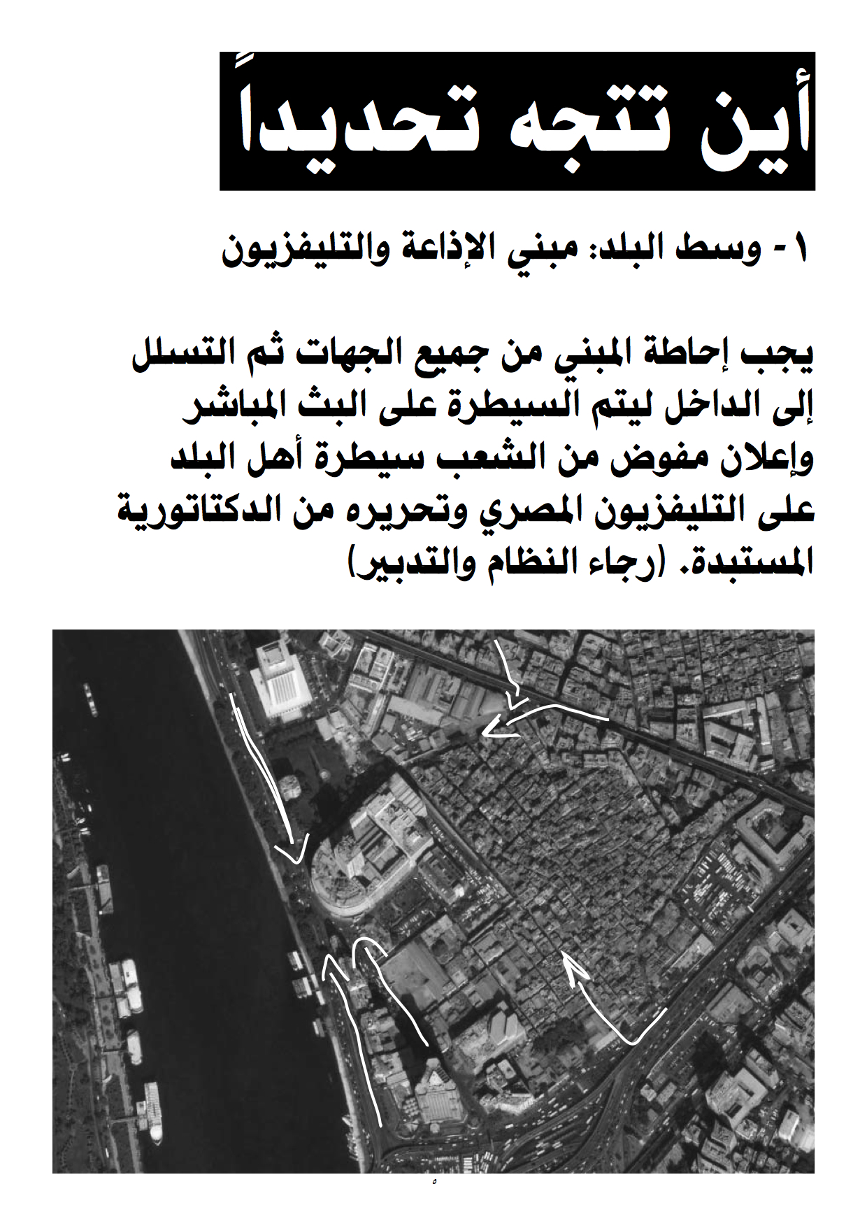
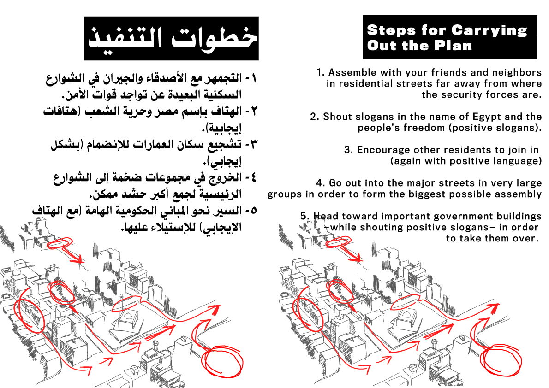

Figure 1: ‘How to demonstrate intelligently’ (Cairo, January 2011)

The physical focus of the demonstrations in Cairo was Midan al-Tahrir, which the Mubarak regime had systematically hollowed out and dismembered in an attempt to deny citizens access to what was nominally public space. This was part of a concerted programme to contain or fragment places of everyday interaction, and it was confined neither to Cairo nor to Egypt. Nasser Rabbat argues more generally that as authoritarian rule was consolidated in the second half of the twentieth century ‘public life in Arab cities retreated from the open spaces to the private ones’, so much so, indeed, that Hussam Hussein Salama suggests that for many Egyptians during those decades ‘public space’ came to be synonymous with ‘the space that is owned by the government’. The square, at the heart of modern, downtown Cairo, had been the site of demonstrations since February 1946 when protesters rallied in what was then called Ismailia Square to demand the withdrawal of British troops from Egypt and the Sudan. They met with a violent response from the police and the army, and the square became known popularly as Midan al-Tahrir (‘Freedom’ or ‘Liberation’ Square). In the 1960s Nasser determined that this would be its official name, and the square continued to be a focus for political demonstrations long after his death: occupied by the student movement in 1972 demanding political and economic reforms, by sympathisers with the second Intifada in the winter of 2001-2002, by thousands of people protesting Mubarak’s support for the US-led invasion of Iraq in March 2003, and by demonstrators demanding political and legal reforms in 2005 and again in 2006.

But these protests were all physically and politically contained by the regime. More and more of the site was fenced off and placed out of bounds, while state-directed urban planning worked in tandem with the Emergency Law limiting demonstrations to choke off the public spaces in which the capillaries of political life could flourish. Mohamed Elshahed provides an illuminating vignette that illustrates the spatial politics practiced by the state in Tahrir. When the plaza in front of the former Egyptian Museum was fenced off many people thought this was part of the construction for the new Cairo Metro. More than a decade later a sign was put up announcing the excavation of a new underground parking garage. Yet when activists dismantled the fencing in January 2011 they found nothing but an empty space. ‘The area had been taken away from the public sphere precisely to avoid the possibility of large crowds congregating in Tahrir.’

This brutal securitization and sequestration of public space was directly challenged by the occupation of Tahrir from 25 January. The protesters courageously refused the circumscription of the public sphere, reclaimed one of its most pivotal physical sites, and became what Tawil-Souri identifies as ‘the very architecture and embodiment of civicness.’

Reciprocities and the performance of space

That is a wonderfully resonant phrase that combines the materiality of the square and the corporeality of its occupants, but to amplify its implications we need to trouble the divisions between the digital public sphere and the physical public space that the previous paragraphs have installed. For there were reciprocities between the virtual and the physical – between the screen and the scene, if you will – that were by no means incidental to the emergence of those new forms of the social and political to which Sassen wants to direct our attention. Writing from Cairo in March 2011, Brian Edwards recalled that when the Internet was blocked ‘the sense of being cut off from their sources of information led many back out on to the street, and especially to Tahrir. With the Internet down, several told me, there was nowhere else to go but outdoors.’ The reverse was also true. ‘The irony of the curfew is that it might succeed in getting people off the streets and out of downtown, but in doing so it delivers them back to the Internet… Many of my friends are on Facebook through the night, as are those I follow on Twitter, a steady stream of tweets and links. Active public discussions and debates about the meanings of what is taking place during the day carry on in cyberspace long after curfew.’
In the same essay Edwards reflects on the compression of meaning imposed by the 140-character limit of each tweet, and he suggests that the immediacy and urgency that this form implies – even imposes – ‘calls forth an immediate, almost unmediated response, point, counterpoint and so on.’ This is a persuasive suggestion, but that response is surely to be found not only virtually (from tweets in cyberspace) but also viscerally (from bodies in the streets). When we see maps like Figure 2, for example, showing tweets in Cairo, we need to recognize that that these are not merely symbols in cartographic space or even messages in cyberspace: they are also markers of a corporeal presence.

This matters because the urban space where ‘newness’ might enter the world does not pre-exist its performance. Some writers examine what, following Henri Lefebvre and David Harvey, might be called the production of space, which would include the construction and re-development of Tahrir as an abstract space through which an instrumental rationality was imposed on the vital heart of the city. As I have said, Tahrir was reduced to a space of circulation not communication, a traffic of vehicles not ideas, regulated by the security apparatus not the civic body. Others, also following in some part Lefebvre, prefer to elucidate spatial practices, including the rhythms and routines that compose everyday life for a myriad of ordinary people in Cairo, residents and visitors, as they moved into, around and out of Tahrir. But to emphasize the performance of space – in the sense that I want to invoke here – is to focus on the ways in which, as Judith Butler put it in direct reference to Tahrir, ‘the collective actions [of the crowd] collect the space itself, gather the pavement, and animate and organize the architecture.’

There are other, more conventionally dramaturgical senses of performance that take their cue from the model proposed by Erving Goffman, and which extend ideas of scripting, role, stage and audience beyond the proscenium arch into the realm of the social. These are useful analytical tropes, but they typically treat the stage as a given: the empty space of Tahrir transformed into director Peter Brooks ‘empty space’ on which action – the ‘real’ drama – unfolds. But action also takes place, and Butler’s sense of the crowd, in all its multiplicity, ‘collecting space’ and so gathering itself speaks directly to a more performative sense of space: one in which action (and its precarious performativity, the effects it brings into being) cannot be severed from the space through which it is achieved. In case this should seem alien, something of what is entailed can be found in Lefebvre’s celebration of the ‘festivals’ that he believed distinguished the counter-cultural realm of ‘spaces of representation’ and their defiant re-placing of bodies-in-spaces. His formulations were, inevitably, creatures of their time – and in particular the moment and movements of May ’68 in Europe and the United States – but they capture the sense of experimentation, of improvisation and of fluidity that also characterised the Arab uprisings. If those newer, non-Western protests heralded a world in which all that was solid melted into air, however, this was more than a new politics of modernity; it was also a new politics of space, and I think this is captured with artful economy in Adam Ramadan’s (re)description of Tahrir as an encampment, turning it into at once a space and an act: a space-in-process.

This is the core of Butler’s thesis. It is an intricate yet in places telegraphic argument that depends in part on a critical engagement with Hannah Arendt’s discussion of political action as what she called the ‘space of appearance’: for Butler, the space of appearance is precisely not ‘a location that can be separated from the plural action that brings it about.’ She sharpens two vital points about Tahrir.

First, the presence of bodies in the square was not only the defiant assertion of a political right that had been denied to ordinary people – not least the right to gather free of intimidation and the threat of violence – but also the performance of a new spatiality through which people

‘seize upon an already established space permeated by existing power, seeking to sever the relation between the public space, the public square, and the existing regime. So the limits of the political are exposed, and the link between the theatre of legitimacy and public space is severed; that theatre is no longer unproblematically housed in public space, since public space now occurs in the midst of another action, one that displaces the power that claims legitimacy precisely by taking over the field of its effects…. In wresting that power, a new space is created, a new “between” of bodies, as it were, that lays claim to existing space through the action of a new alliance, and those bodies are seized and animated by those existing spaces in the very acts by which they reclaim and resignify their meanings.’

I read this choreography of newness entering the world, the formation of a new, collective subject-in-space-in-process so to speak, as a riff on Tawil-Souri’s ‘architecture and embodiment of civicness’, as a celebration of both the civic engagement displayed in the organization of food distribution, medical care and sanitation and the political engagement activated by the posters, artwork, music and discussions. But in Butler’s formulation it is also about ‘collecting the space’ in order to ‘gather’, as a means of gathering. May Al-Ibrashy intimated something of this when she wrote of Tahrir on 9 February 2011 that there ‘permanence is folded into waves of change. The cityscape is no longer … an open space framed by buildings, but a constantly morphing place shaped by people doing, hoping, building, destroying and being’ – or, more accurately, I believe, becoming. As Nasser Abourahme and May Jayyusi wrote in exuberant endorsement, ‘Tahrir Square was the space of the constitution of new collective subjectivities… There was a kind of “becoming” here…’

Even more than this – and Butler’s second point – Tahrir became the instantiation of what Doreen Massey once called ‘a global sense of place’, an intricate and intrinsically mobile constellation of the local and the global. In Butler’s terms, this new spatiality became ‘transposable’, which is to say that its performance was at once immediate and mediated. The conjunction of social media and satellite television ensured that what took place (literally so) in Tahrir was relayed around the world. This involved more than the consecration of ‘Tahrir’ as an iconic site, because those sounds and images from the Square together with the distant responses that they elicited found their way back into – affirmed and emboldened – the performance of Tahrir as both a physical and a corporeal place. And yet at the same time there remained something localized that could not be transported. Tweets took flight, but their senders did not. ‘If [people] are transported in one way,’ Butler reminds us, ‘they are surely left in place in another, holding the camera or the cell phone, face to face with those they oppose, unprotected, injurable, injured, persistent, if not insurgent.’ To repeat: these achievements – the installation of Sassen’s ‘global street’ – were precarious and conditional, and as a counter-revolution tries to unfold in Cairo, crushing bodies-in-spaces, so these fragile localizations testify to the intimate relations between their precarious spaces and what Butler calls ‘precarious life’. Mona Abaza has shown how, since November 2011, the state apparatus has attempted to contain ‘localized war-zones’ through the erection of barricades and walls, so that spaces-in-process once again congeal rather than actively congregate.

The other side of the street

I have paid so much attention to Butler’s remarks as a preliminary answer to the question I posed at the beginning of this essay for two reasons. First, for me, they are precisely not about metropolitan High Theory being used as a conceptual grid to domesticate the political actions of people elsewhere in the world. Instead, they suggest that those of us who inhabit the privileges that are attached to sectors of Europe and North America need to learn from the events in Tunisia, Egypt, Algeria, Bahrain and Syria that the contemporary public sphere depends not on a digital repertoire alone (important though that is) but also on brave bodies-in-alliance installing new spaces through the conjuncture of what Butler calls ‘street and media’.

Second, her insistence on this combination – and on the bodily harms that too often attend upon it – should alert us to the actions of others who are learning from these events too. The US military and the Israel Defense Forces are no strangers to digital warfare, to the use of digital technologies in war zones to track and target their enemies, and, in the case of Israel, to digital occupation. But they have also become aware of the power of social media: both of them regularly upload edited video to YouTube, and both can be followed on Facebook and Twitter. And at least some senior officers have been persuaded that, in the words of one of them, ‘the Arab Spring has profound implications for the US Special Operations mission of unconventional warfare’ that need to be incorporated into ‘theory, doctrine and training’. Standard ‘red force tracking’ in which the enemy is caught in a net of electronic surveillance must now be complemented by ‘social tracking’ in which social media are monitored and even enlisted. The standard image of unconventional war, the same officer concludes, is of ‘underground resistance leaders meeting with US advisers, clustered in a dark basement around a crumpled map, secretly organizing and planning their next tactical move.’ But this is now incomplete, and future operations will need to enlist ‘a scattered network of digerati, all texting, tweeting, posting and hacking from thousands of locations. Publicity is as paramount to the success of the digerati as is secrecy vital to the success of the traditional underground resistance cell.’ I’m sure I don’t need to dwell on which ‘resistance leaders’ are likely to be meeting with US advisers, nor on the bodily consequences for those on the other side of the street.

References

Abaza, Mona (2013) ‘Walls, Segregating Cairo and the Mohammed Mahmud Street graffiti’, Theory, culture and society 30: 122-39

Abourahme, Nasser and May Jayyus (2011), ‘The will to revolt and the spectre of the Real: Reflections on the Arab moment’, City 15 (6) 625-630.

Al-Ibrashy, May (2011) ‘Days of the Midan’, Magaz 401.

Amar, Paul (2011) ‘Why Mubarak is out’, at http://www.jadaliyya.com/pages/index/516/why-mubarak-is-out, 1 February.

Barrons, Genevieve (2012) ‘Suleiman: Mubarak decided to step down #egypt #jan25 OH MY GOD’: examining the use of social media in the 2011 Egyptian revolution’, Contemporary Arab Affairs 5: 54-67.

Bhabha, Homi (1994) The location of culture (London and New York: Routledge).

Butler, Judith (2004) Precarious life: the powers of mourning and violence (London and New York: Verso).

Butler, Judith (2011) ‘Bodies in alliance and the politics of the street’, at http://eipcp.net/transversal/1011/butler/en.

Dunn, Alexandra (2011) ‘Unplugging a nation: state media strategy during Egypt’s January 25 Uprising’, Fletcher Forum of World Affairs 35 (2) 15-24.

Edwards, Brian (2011) ‘Tahrir: ends of circulation’, Public culture 23 (3) 493-504.

El-Ghobashy, Mona (2011)‘The praxis of the Egyptian Revolution’, Middle East Report 258 pp. 2-13.

Elshahed, Mohamed (2011) ‘Tahrir Square: social media, public space’, http://places.designobserver.com/feature/tahrir-square-social-media-public-space/25108/ 27 February.

Elshahed, Mohamed (2011) ‘Urbanizing the counter-revolution’, Jadaliyya 17 December.

Fahmi, Wael Salah (2009) ‘Bloggers’ street movement and the right to the city: (re)claiming Cairo’s real and virtual “spaces of freedom”’, Environment and Urbanization 21 (1) 89-107.

Foucault, Michel (1980) Questions on Geography’, in Power/Knowledge: selected interviews and other writings, 1972-1977 (trans. Colin Gordon) (New York: Pantheon) pp. 63-77.

Gregory, Derek (1994) Geographical imaginations (Oxford: Blackwell).

Gregory, Derek (2010) ‘Seeing Red: Baghdad and the event-ful city’, Political Geography 29: 266-279.

Gregory, Derek (2005) ‘Performing Cairo: Orientalism and the city of the Arabian Nights’, in Nezar Al-Sayyad, Irene Bierman and Nasser Rabat (eds): Making Cairo Medieval (Lanham MD: Lexington Books/Rowman and Littlefield) pp. 69-93.

Howard, Philip and Muzammil Hussain (2011), ‘The role of digital media’, Journal of Democracy 22 (3) 35-48.

Jameson, Frederic (1991) Postmodernism, or the cultural logic of late capitalism (London: Verso; Durham NC: Duke University Press).

Joseph, Sarah (2012) ‘Social media, political change and human rights’, Boston College International and Comparative Law Review 35 (1) pp. 145-88.

Kanna, Ahmed (2012) ‘Urban praxis and the Arab Spring’, City 16 (3) 360-8.

Khondker, Habibul Haque (2011), ‘Role of the new media in the Arab Spring’, Globalizations 8: 675-679.

Kuntsman, Adi and Rebecca Stein (2010), ‘Another war zone: social media in the Israeli-Palestinian conflict’, Middle East Research and Information Project, September at http://www.merip.org/mero/interventions/another-war-zone.

Kuntsman, Adi and Rebecca Stein (2011) ‘Digital suspicion, politics and the Middle East’, http://dukespace.lib.duke.edu/dspace/bitstream/handle/10161/6782/Digital_suspicion_Kuntsman_and_Stein.pdf?sequence=1

Lefebvre, Henri (1974) La production de l’espace (Paris: Anthropos); trans. as The production of space (Oxford: Blackwell, 1991).

Massey, Doreen (1994) Space, place and gender (Cambridge UK: Polity Press; Minneapolis: University of Minnesota Press).

Mitchell, W.J.T. (2012) ‘Image, space, revolution: the arts of occupation’, Critical Inquiry 39: 8-32.

Pettit, Brian (2012) “Social media and U[nconventional] W[arfare]’, Special Warfare 25 (2) at http://www.soc.mil/swcs/swmag/archive/SW2502/SW2502SocialMediaAndUW.html.

Rabat, Nasser (2012) ‘The Arab Revolution takes back the public space’, Critical Inquiry 39 (1) 198-208.

Ramadan, Adam (2013) ‘From Tahrir to the world: the camp as a political public space’, European Urban and Regional Studies 20 145-9.

Rose, Gillian (1999) ‘Performing space’, in Doreen Massey, John Allen and Philip Sarre (eds), Human geography today (Cambridge UK: Polity Press) pp. 247-259.

Salama, Hussam Hussein (2013) ‘Tahrir Square: a narrative of public space’, Archnet-IJAR 7 (1) 128-138.

Salvatore, Armando (2013) ‘New media, the “Arab Spring” and the metamorphosis of the public sphere: beyond Western assumptions on collective agency and democratic politics’, Constellations 20 (2) 1-12.

Sassen, Sakia (2011) ‘The global street: making the political’, Globalizations 8: 573-9.

Stein, Rebecca (2011) ‘The Other Wall’, London Review of Books 19 April 2011.

Tawil-Souri, Helga (2012) ‘Digital occupation: Gaza’s high-tech enclosure’, Jnl. Palestine Studies 41 (2) 27-43.

Tawil-Souri, Helga (2012) ‘It’s still about the power of place’, Middle East Journal of Culture and Communication 5: 86-95.

Tripp, Charles (2013) ‘Performing the public: theatres of power in the Middle East’, Constellations doi: 10.1111/cons.12030.

Tufekci, Zeynep and Christopher Wilson (2012) ‘Social media and the decision to participate in political protest: Observations from Tahrir Square’, Journal of Communication 62: 363-79.

Woodcock, Bill (2011) ‘Overview of the Egyptian Internet Shutdown’, Packet Clearing House at http://www.pch.net/resources/misc/Egypt-PCH-Overview.pdf, February 2011.

† I am grateful to Oliver Belcher and Craig Jones for comments on an early draft of this essay.
Saskia Sassen, ‘The global street: making the political’, Globalizations 8 (2011) 573-9.
Homi Bhabha, ‘How newness enters the world’, in his The location of culture (London and New York: Routledge, 1994) 212-235. The reference to Bhabha is not arbitrary; here he engages – critically – with Frederic Jameson’s spatial thematics and in particular the difficulty Jameson registered in mapping/visualizing the new global space of decentered, networked communications that appeared to him as the leitmotif of late capitalism: Frederic Jameson, Postmodernism, or the cultural logic of late capitalism (London: Verso; Durham NC: Duke University Press, 1991). Jameson’s original voyage of disorientation was published in 1984; thirty years later other generations of voyageurs have devised new ways of navigating these currents, and – as the events in Tunisia, Egypt and elsewhere have shown – some of them have demonstrated a remarkable capacity to direct these decentered, networked systems against the colonizing, neo-liberalizing logics of an even later capitalism and its authoritarian armatures. Significantly for my purposes, however, Jameson also uses a physical space – the Bonaventure Hotel in Los Angeles –as a figure of this new ‘hyperspace’.
Michel Foucault, ‘Questions on Geography’, in Power/Knowledge: selected interviews and other writings, 1972-1977 (trans. Colin Gordon) (New York: Pantheon, 1980) pp. 63-77; the interview with Foucault was conducted by the editors of Hérodote in 1976.
Armando Salvatore, ‘New media, the “Arab Spring” and the metamorphosis of the public sphere: beyond Western assumptions on collective agency and democratic politics’, Constellations 20 (2) (2013) 1-12; Wael Salah Fahmi, ‘Bloggers’ street movement and the right to the city: (re)claiming Cairo’s real and virtual “spaces of freedom”’, Environment and Urbanization 21 (1) (2009) 89-107.
A barbed joke circulating in Cairo had Omar Suleiman, Mubarak’s former intelligence chief and then a presidential candidate, adopting as his slogan ‘You are all Khaled Said’.
For detailed discussions see Genevieve Barrons, ‘Suleiman: Mubarak decided to step down #egypt #jan25 OH MY GOD’: examining the use of social media in the 2011 Egyptian revolution’, Contemporary Arab Affairs 5 (2012) 54-67; Philip Howard and Muzammil Hussain, ‘The role of digital media’, Journal of Democracy 22 (3) (2011) 35-48; Habibul Haque Khondker, ‘Role of the new media in the Arab Spring’, Globalizations 8 (2011) 675-679; Zeynep Tufekci and Christopher Wilson, ‘Social media and the decision to participate in political protest: Observations from Tahrir Square’, Journal of Communication 62 (2012) 363-79.
For an extended and incisive discussion, see Sarah Joseph, ‘Social media, political change and human rights’, Boston College International and Comparative Law Review 35 (1) (2012) pp. 145-88.
I use the collective phrase as a short-hand; for a careful dissection of what he calls ‘the moving parts within the military and police institutions of Egypt’s security state’, see Paul Amar, ‘Why Mubarak is out’, at http://www.jadaliyya.com/pages/index/516/why-mubarak-is-out, 1 February 2011.
This narrative is based on Philip Howard and Muzammil Husain, ‘The role of digital media’, Journal of democracy 22 (3) (2011) 35-48; Alexandra Dunn, ‘Unplugging a nation: state media strategy during Egypt’s January 25 Uprising’, Fletcher Forum of World Affairs 35 (2) (2011) 15-24; Bill Woodcock, ‘Overview of the Egyptian Internet Shutdown’, Packet Clearing House at http://www.pch.net/resources/misc/Egypt-PCH-Overview.pdf, February 2011.
Mona El-Ghobashy, ‘The praxis of the Egyptian Revolution’, Middle East Report 258 (2011) pp. 2-13.
Helga Tawil-Souri, ‘It’s still about the power of place’, Middle East Journal of Culture and Communication 5 (2012) 86-95; Tufekci and Wilson, ‘Observations from Tahrir Square’, Journal of Communication 6 (2012) 363-79.
The original 26-page pamphlet from which the illustrations in Figure 1 are taken can be found at http://publicintelligence.net/egyptian-revolution-protest-manual-how-to-protest-intelligently; it was circulated in Cairo in January 2011. A translated version of some of the pages is available at http://cdn.theatlantic.com/static/mt/assets/science/Page%204_rev.jpg
Nasser Rabat, ‘The Arab Revolution takes back the public space’, Critical Inquiry 39 (1) (2012) 198-208; Hussam Hussein Salama, ‘Tahrir Square: a narrative of public space’, Archnet-IJAR 7 (1) (2013) 128-138
This was ‘Evacuation Day’ whose counterpart was the ‘Day of Departure’ called by demonstrators in the same square for 3 February 2011; Mubarak finally resigned eight days later.
Mohamed Elshahed, ‘Tahrir Square: social media, public space’, http://places.designobserver.com/feature/tahrir-square-social-media-public-space/25108/ 27 February 2011.
Tawil-Souri, ‘Power of place’. Rabat adds a rider: for him, the uprisings facilitated what he calls ‘a kind of dialogue between the spaces of tradition and the spaces of modernity’. He has in mind a much older public space in cities under the sign of Islam – that of the mosque, where the adult male population met to pray, to learn but also to exercise their political rights – and suggests that its customary usages were re-enlisted to sustain the instantiation of a new, democratic and radically non-patriarchal form of politics in the square. Put more simply, mosques were relatively safe gathering grounds from which protesters could issue and converge upon the square. Sassen similarly argues that the mosques provided the ‘foundational communication network’ for the Friday mobilizations.
Brian Edwards, ‘Tahrir: ends of circulation’, Public culture 23 (3) (2011) 493-504; Salvatore, ‘New media’, suggests that this va-et-vient had been in place for five or six years, and that ‘since the mid-2000s virtual and public spaces came into a mutual synergy and produced a formidable potential for mobilizing a broad variety of actors’: it was precisely that potential that was realized in the occupation of Tahrir in 2011.
Edwards, ‘Tahrir’; here he is quoting Dilip Parameshwar Gaonkar.
This map comes from a series in 2011 and 2012 posted at http://web3lab.blogspot.ca. The real-time sequence of SMS mapped by the Digital Humanities Project at UCLA is even more effective, but the images are too large to be reproduced here: seehttp://egypt.hypercities.com.
Judith Butler, ‘Bodies in alliance and the politics of the street’, at http://eipcp.net/transversal/1011/butler/en. Much of Butler’s work has involved the development of the concept of performativity to show how gender and other subject-ascriptions are inscribed on the body through performance, but this is the first essay (in fact the text of a lecture delivered in Venice in September 2011) in which she extends her formulations from the subject to the subject-in-space.
In relation to Tahrir, see Charles Tripp, ‘Performing the public: theatres of power in the Middle East’, Constellations (2013) doi: 10.1111/cons.12030. Tripp does acknowledge Butler en passant, but his exposition of what he calls ‘the dramaturgy of performance’ renders the space of the Square more or less inert. For an altogether different reading of Tahrir as ‘empty space’, see W.J.T. Mitchell, ‘Image, space, revolution: the arts of occupation’, Critical Inquiry 39 (2012) 8-32: pp. 18-22.
For a fuller theoretical discussion see Gillian Rose, ‘Performing space’, in Doreen Massey, John Allen and Philip Sarre (eds), Human geography today (Cambridge UK: Polity Press, 1999) pp. 247-259; I have elaborated these ideas in ‘Performing Cairo: Orientalism and the city of the Arabian Nights’, in Nezar Al-Sayyad, Irene Bierman and Nasser Rabat (eds): Making Cairo Medieval (Lanham MD: Lexington Books/Rowman and Littlefield, 2005) pp. 69-93.
Henri Lefebvre, La production de l’espace (Paris: Anthropos, 1974; 1981); trans. As The production of space (Oxford: Blackwell, 1991); I have provided a detailed discussion in Geographical imaginations (Oxford: Blackwell, 1994). For other attempts to mobilise Lefebvre in Tahrir, see Ahmed Kanna, ‘Urban praxis and the Arab Spring’, City 16 (3) (2012) 360-8 and especially Salama, ‘Tahrir Square’, who diagrams Tahrir through Lefebvre’s tripartite schema of perceived, conceived and lived space (p 133 on).
Adam Ramadan, ‘From Tahrir to the world: the camp as a political public space’, European Urban and Regional Studies 20 (2013) 145-9. Mitchell, ‘Image, space, revolution’, makes a similar claim in a different register. He toys with the figure of encampment too, but ultimately prefers ‘occupation’. It works in a similar way, I think, and both authors emphasise that these performances of space, as I’m calling them here, across the Middle East and North Africa, subverted an older, Western, and profoundly colonial sense of order and occupation that had been continued into the ‘post’-colonial.
Butler, ‘Bodies in alliance’.
May Al-Ibrashy, ‘Days of the Midan’, Magaz 401 (2011) at http://www.magazmagazine.com/magaz2012/index.php?option=com_content&view=article&id=700%3Adays-of-the-midan&catid=157%3Aissue-401&Itemid=123&task=view; Nasser Abourahme and May Jayyusi, ‘The will to revolt and the spectre of the Real: Reflections on the Arab moment’, City 15 (6) (2011) 625-630..
Doreen Massey, ‘A global sense of place’, in her Space, place and gender (Cambridge UK: Polity Press; Minneapolis: University of Minnesota Press, 1994) 146-156.
Butler, ‘Bodies in alliance’.
Judith Butler, Precarious life: the powers of mourning and violence (London and New York: Verso 2004); on the counter-revolution in Cairo, and the attempt to normalize urban violence, see Mohamed Elshahed, ‘Urbanizing the counter-revolution’, Jadaliyya 17 December 2011.
Mona Abaza, ‘Walls, Segregating Cairo and the Mohammed Mahmud Street graffiti’, Theory, culture and society 30 (2013) 122-39.
Derek Gregory, ‘Seeing Red: Baghdad and the event-ful city’, Political Geography 29 (2010) 266-279; Helga Tawil-Souri, ‘Digital occupation: Gaza’s high-tech enclosure’, Jnl. Palestine Studies 41 (2) (2012) 27-43;
Adi Kuntsman and Rebecca Stein, ‘Another war zone: social media in the Israeli-Palestinian conflict’, Middle East Research and Information Online at http://www.syria.jadaliyya.com/pages/index/3581/urbanizing-the-counter-revolution, September 2010; Rebecca Stein, ‘The Other Wall’, London Review of Books 19 April 2011 at http://www.lrb.co.uk/blog/2011/04/19/rebecca-l-stein/the-other-wall.
Lt Col Brian Pettit, “Social media and U[nconventional] W[arfare]’, Special Warfare 25 (2) 2012 at http://www.soc.mil/swcs/swmag/archive/SW2502/SW2502SocialMediaAndUW.html. This is a vivid rebuttal of the ‘cyber-utopianism’ to which Adi Kuntsman and Rebecca Stein so forcefully and persuasively dissent: ‘Digital suspicion, politics and the Middle East’, Critical Inquiry (2011).

